**Data Flow Diagrams:**

**Project Design Phase-II**

**Data Flow Diagram & User Stories**

|  |  |
| --- | --- |
| Date | 16 October 2022 |
| Team ID | PNT2022TMID48024 |
| Project Name | Personal Expense Tracker Application |
| Maximum Marks | 4 Marks |

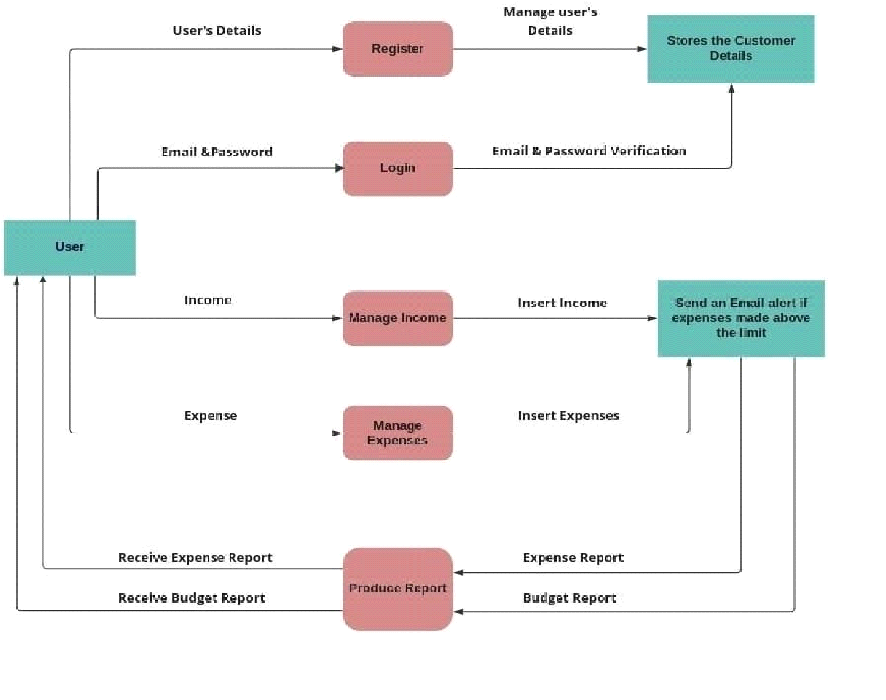

**User Stories :-**

|  |  |  |  |  |  |  |
| --- | --- | --- | --- | --- | --- | --- |
| **User Type** | **Functional Requireme**  **nt (Epic)** | **User**  **Story**  **Numb**  **er** | **User Story / Task** | **Acceptance**  **criteria** | **Priorit y** | **Releas**  **e** |
| Custom  er  (Mobile user) | Registration | USN-1 | As a user, I can register to the application by  providing my email, password, and confirming my password. | I can access my account / dashboard | High |  |
|  |  | USN-2 | As a user, I will receive  confirmation email once I have registered for the application | I can receive confirmation email & click confirm | High |  |
|  |  | USN-3 | As a user, I can register for the  application through Facebook | I can register & access the dashboard with Facebook Login | Low |  |
|  | Login | USN-4 | As a user, I can log into the application by entering email & password | I can access the applicati on | High |  |
|  | Dashboard | USN-5 | As a user I can enter my income and expenditure details. | I can view my daily expenses | High |  |
| Custome  r Care Executi ve |  | USN – 6 | As a customer care executive, I can solve the log in issues and other issues of the application. | I can provide support or solution at any time 24*7 | Mediu m |  |